In Class Exercise 4

Rahul Avadhoot

October 18, 2017

data("mtcars")

## Question 1

boxplot(mpg~cyl,data = mtcars,xlab="No. of Cylinders", ylab="Miles/gallon", main="Boxplots of MPG vs Cylinders",col=topo.colors(3))  
legend("topright",title="Number of Cylinders",c("4","6","8"),fill=topo.colors(3))

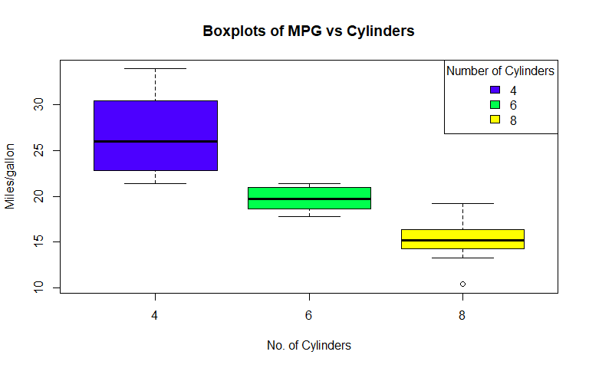

## Question 2

### Part (a)

plot(mpg~wt,data = mtcars,xlab="Weight (1000 lbs)", ylab="Miles/gallon",main="Plot of MPG vs Weight")  
abline(40, -6, lwd=3, col = "green")

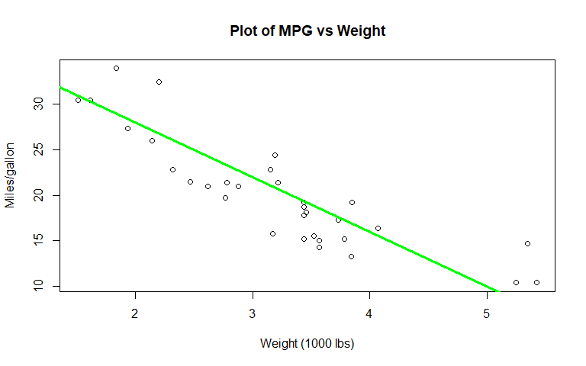

### Part (b)

plot(mpg~wt,data = mtcars,xlab="Weight (1000 lbs)", ylab="Miles/gallon",main="Plot of MPG vs Weight")  
with(mtcars, lines(lowess(wt,mpg), col="red", lwd=3))  
with(mtcars, lines(supsmu(wt,mpg), col="blue", lwd=3))

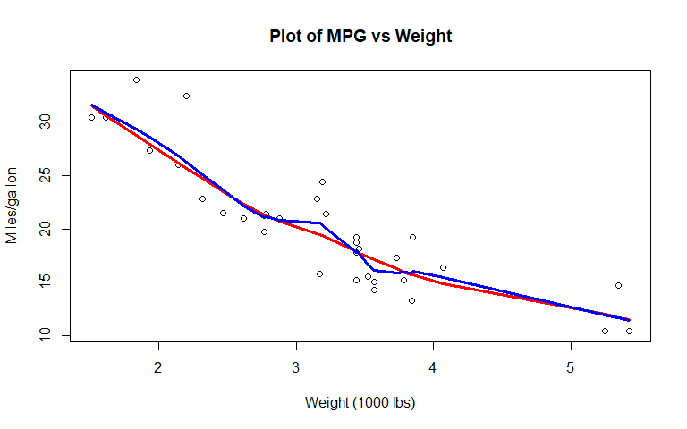

### Part (c)

plot(mpg~wt,data = mtcars,xlab="Weight (1000 lbs)", ylab="Miles/gallon",main="Plot of MPG vs Weight")  
abline(40, -6, lwd=3, col = "green")   
with(mtcars, lines(lowess(wt,mpg), col="red", lwd=3))  
with(mtcars, lines(supsmu(wt,mpg), col="blue", lwd=3))  
legend("topright",title="Legend",c("Straight line","LOWESS","SUPSMU"),col=c("green", "red", "blue"), lwd=2)

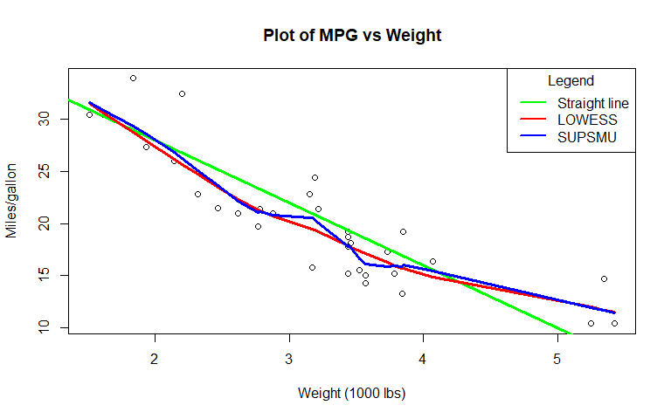

## Question 3

plot(mpg~wt,data = mtcars,xlab="Weight (1000 lbs)", ylab="Miles/gallon",main="Plot of MPG vs Weight")  
abline(40, -6, lwd=3, col = "green")   
with(mtcars, lines(lowess(wt,mpg), col="red", lwd=3, lty = 2))  
with(mtcars, lines(supsmu(wt,mpg), col="blue", lwd=3, lty = 3))  
legend("topright",title="Legend",c("Straight line","LOWESS","SUPSMU"),col=c("green", "red", "blue"), lwd=3, lty = 1:3)

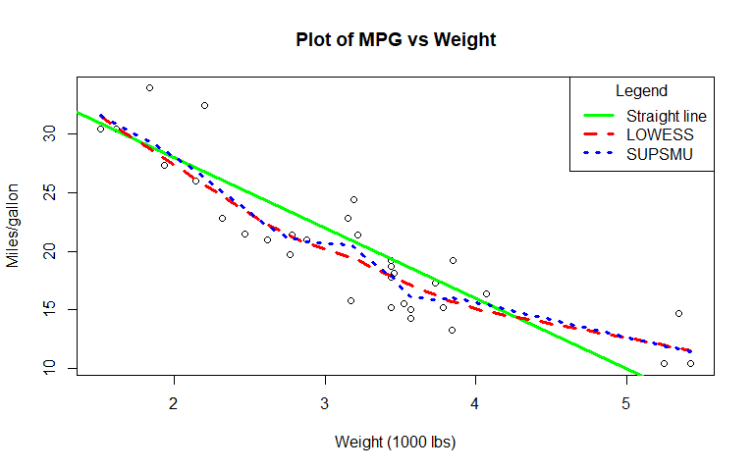

## Question 4

layout(matrix(c(1,1,2,3),2,2,byrow=TRUE))  
  
boxplot(mpg~cyl,data=mtcars,xlab="No. of Cylinders",ylab="Miles/gallon",main="Boxplots of MPG vs Cylinders",col=topo.colors(3))  
legend("topright",title="Number of Cylinders",c("4","6","8"),fill=topo.colors(3))  
  
plot(mpg~wt,data=mtcars,xlab="Weight (1000 lbs)",ylab="Miles/gallon",main="Scatterplot of MPG vs Weight")  
abline(40,-6,lwd=3,col="green")   
with(mtcars,lines(lowess(wt,mpg),col="red",lwd=3))  
with(mtcars,lines(supsmu(wt,mpg),col="blue",lwd=3))  
legend("topright",title="Legend",c("Straight line","LOWESS","SUPSMU"),col=c("green","red","blue"),lwd=2)  
  
plot(mpg~wt,data = mtcars,xlab="Weight (1000 lbs)",ylab="Miles/gallon",main="Scatterplot of MPG vs Weight")  
abline(40,-6,lwd=3,col="green")   
with(mtcars,lines(lowess(wt,mpg),col="red",lwd=3,lty=2))  
with(mtcars,lines(supsmu(wt,mpg),col="blue",lwd=3,lty=3))  
legend("topright",title="Legend",c("Straight line","LOWESS","SUPSMU"),col=c("green","red","blue"),lwd=2,lty=1:3)

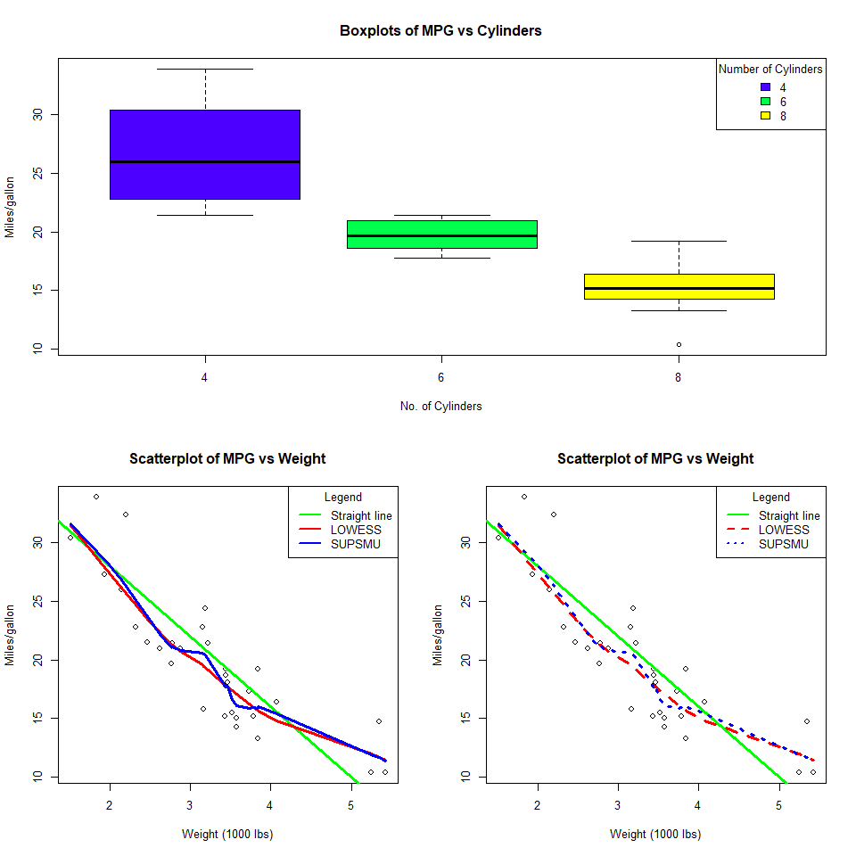

Saving above plot as a PDF

pdf("InClassExercise4Plot.pdf")  
layout(matrix(c(1,1,2,3),2,2,byrow=TRUE))  
  
boxplot(mpg~cyl,data=mtcars,xlab="No. of Cylinders",ylab="Miles/gallon",main="Boxplots of MPG vs Cylinders",col=topo.colors(3))  
legend("topright",title="Number of Cylinders",c("4","6","8"),fill=topo.colors(3))  
  
plot(mpg~wt,data=mtcars,xlab="Weight (1000 lbs)",ylab="Miles/gallon",main="Scatterplot of MPG vs Weight")  
abline(40,-6,lwd=2,col="green")   
with(mtcars,lines(lowess(wt,mpg),col="red",lwd=2))  
with(mtcars,lines(supsmu(wt,mpg),col="blue",lwd=2))  
legend("topright",title="Legend",c("Straight line","LOWESS","SUPSMU"),col=c("green","red","blue"),lwd=2)  
  
plot(mpg~wt,data = mtcars,xlab="Weight (1000 lbs)",ylab="Miles/gallon",main="Scatterplot of MPG vs Weight")  
abline(40,-6,lwd=2,col="green")   
with(mtcars,lines(lowess(wt,mpg),col="red",lwd=2,lty=2))  
with(mtcars,lines(supsmu(wt,mpg),col="blue",lwd=2,lty=3))  
legend("topright",title="Legend",c("Straight line","LOWESS","SUPSMU"),col=c("green","red","blue"),lwd=2,lty=1:3)  
dev.off()

## png   
## 2